**Market Website User Manual**

**Developer: Calvin Tang**

**Register Page**

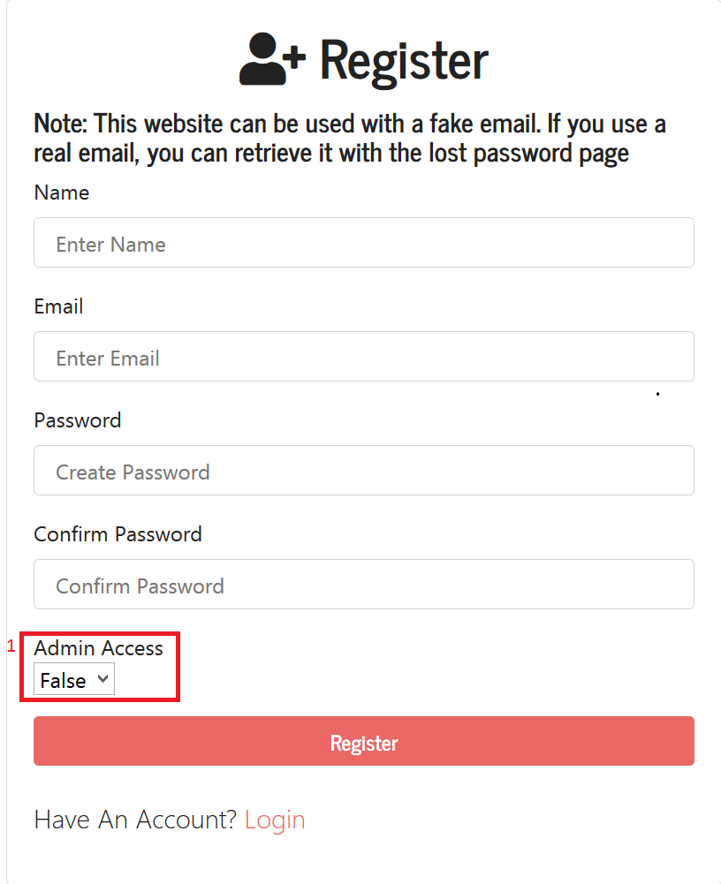

1: If this is False, you will not be able to access the admin page.

**Login Page**

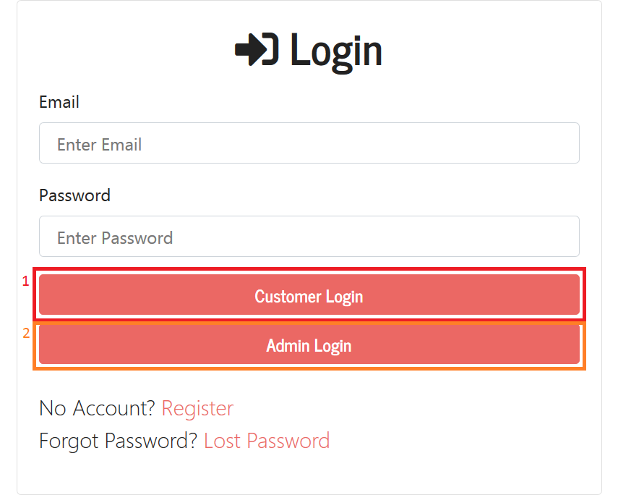1: Redirects to the customer page

2: Redirects to the admin page. If you are not an admin it will redirect you to the customer page.

**Lost Password Page**

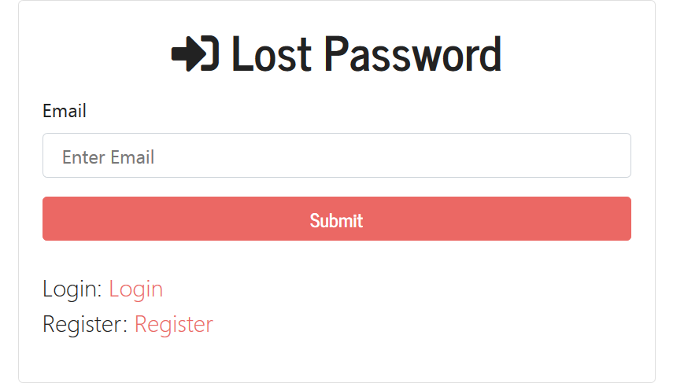

This page will send an email to your username (which is an email address) with a random token string to start the process of resetting your password.

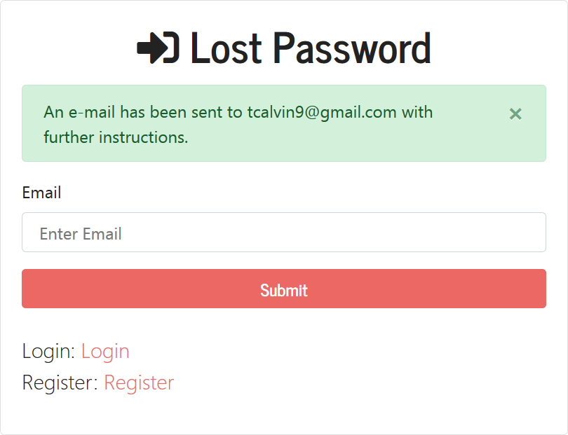

After submitting your email (if authentic), you will receive an email with a link. That email is shown in the picture below

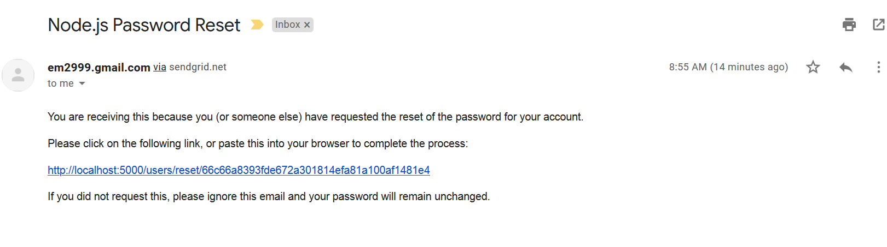

Clicking that link will direct you to the page shown in the picture below

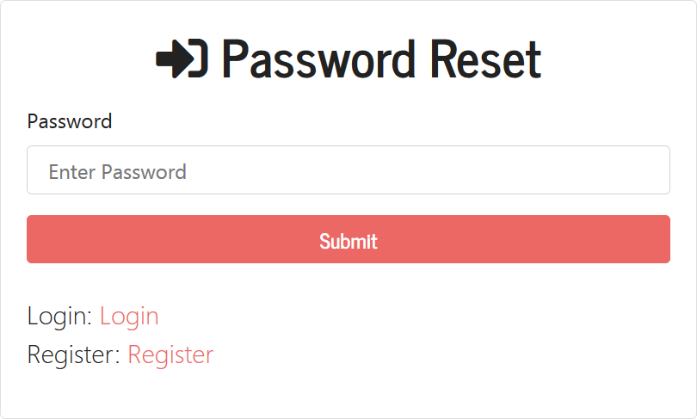

This page will allow you to change your password.

**Admin Page**

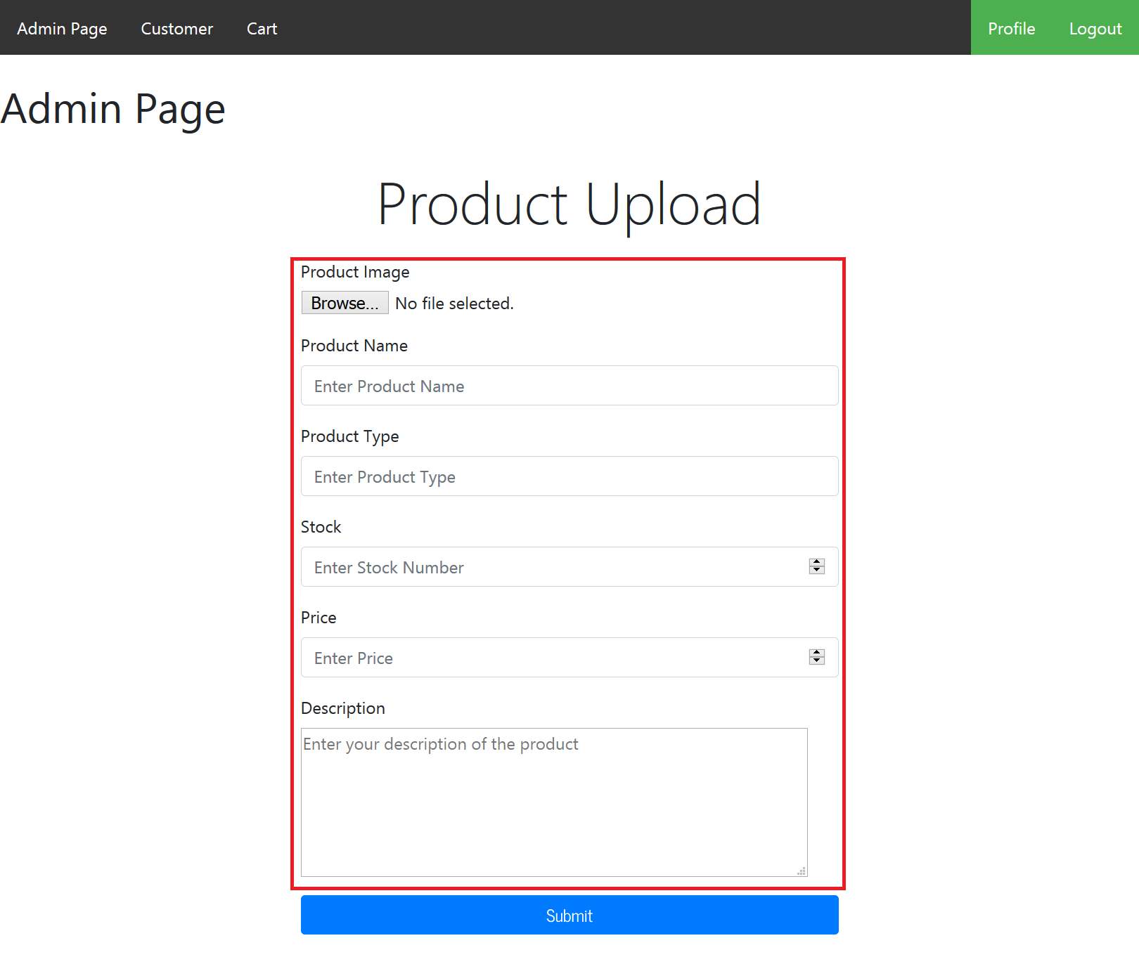

This page allows you to upload a product with an image and its information, as shown in the picture above.

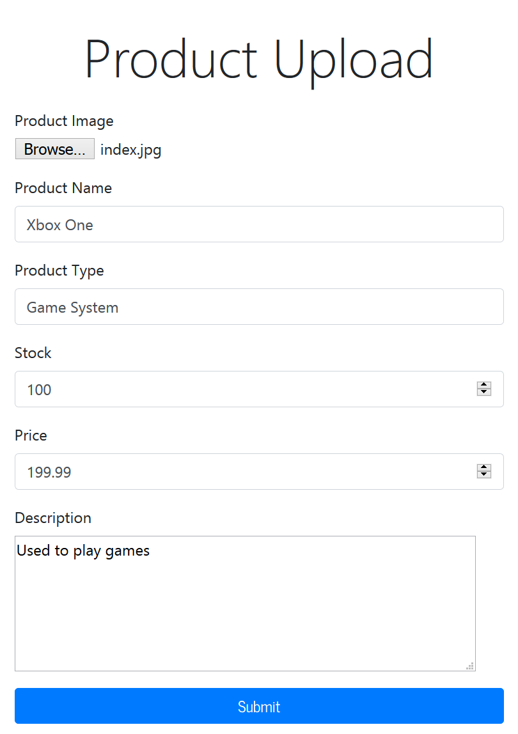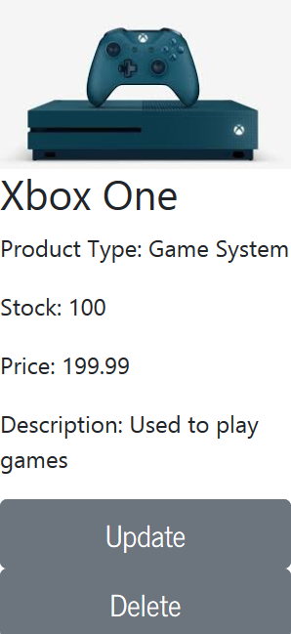’

Filling out the information on the left image will create a product shown in the right image. As an admin you have the authorization to create and add a new product. You also have the power to update existing information or even delete a product as shown on the right image.

**Customer Page**

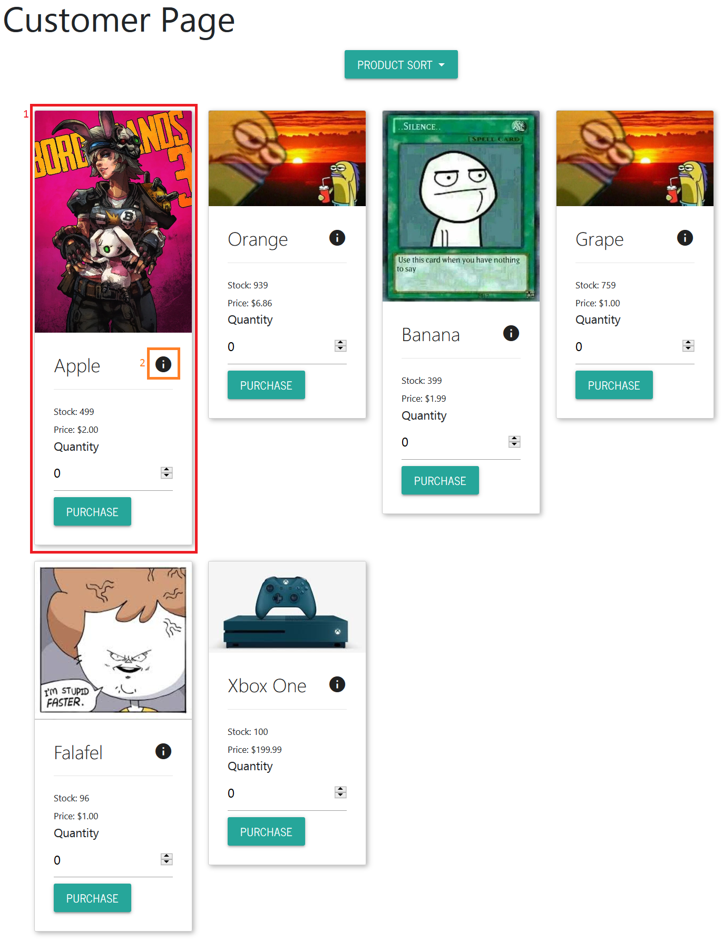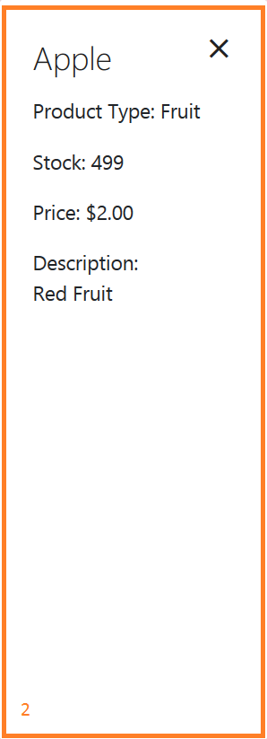

The customer page will allow you to purchase products. The products is shown in the red box with the number one. For more information, you can click the orange box with the number two. The orange encased image on the right is the information that appears when you click the orange box on the left image.

**Cart Page**

After purchasing a product from the customer page.

You can go to the Cart Page to finalize your transaction.

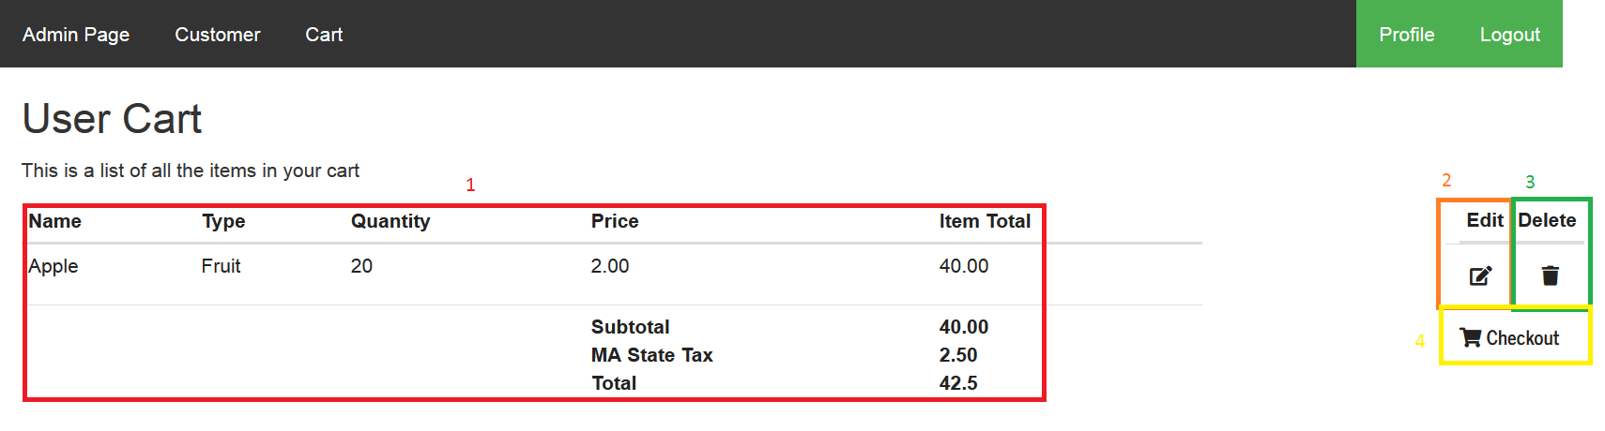

**1:** All of the product information is shown here, including the subtotal, tax, and total.

**2:** The edit function will allow you to remove a portion of your quantity and put it back into the product list in customer. For example, remove 10 apples from your 20.

**3:** The remove function will remove all of the product and put it back into the product list in customer.

4: Checkout will confirm and finalize the transaction and send a receipt to your user email.

The Reciept

